
Affiliate Swipe Pack
The Ultimate Diabetic Cookbook by Denise Campbell
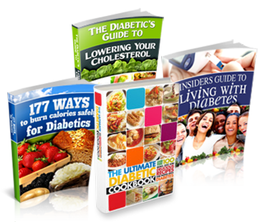
Price: US$37, one payment
Commission: 75%
ClickBank vendor: diabeticcb
Guarantee: 60 days, money back
Affiliate manager: Andrew Rusbatch, andrew@unicapublications.com

Contents
- How to make your hoplink
- Emails (28 emails, 3 subject lines each)
- Hooks & angles (11 angles)
- Social posts (5 posts)
Everything in this pack is ready to copy. Change it so it sounds like you, add your own link, keep the disclosure line, and send it to people who asked to hear from you.

1. How to make your hoplink

1. Build your hoplink
Your hoplink is the link that gets you paid. This is the pattern: https://hop.clickbank.net/?affiliate=YOURID&vendor=diabeticcb&tid=TRACKING&type=main Swap YOURID for your ClickBank ID. Swap TRACKING for a short tag of your own (letters, numbers and underscores) so you can see which email or post made the sale.

2. Where it lands
Every link lands on the sales page (type=main), where the reader sees the full offer before buying. Links never go straight to the order form.

3. Use the generator
If you would rather not type it out, the link generator at https://aff.ultimatediabeticcookbook.com/links/ builds it for you.

4. Fill in the swipes
In the emails, replace YOURIDHERE and YOURTRACKINGHERE inside each [Link this to ...] line with your own details, then make that line a clickable link. In the social captions, replace {HOPLINK} with your hoplink. Replace {!firstname_fix} with the first-name tag your autoresponder uses.

5. Add your own touch
Each email has a line in brackets for one true sentence of your own. Write it. Emails that sound like you do better than copies.

6. Keep the disclosure
Leave the disclosure line in every email and keep #ad (or your platform's paid-partnership label) on every post.

Two rules
- Never write that the cookbook cures, treats or controls diabetes, or that it lowers blood sugar. Never suggest that anyone changes their medicine. It is a cookbook, and that is how we sell it.
- Only email people who have agreed to hear from you, and follow CAN-SPAM. Spammers are reported to ClickBank and banned from promoting the cookbook.

2. Emails
Below you'll find pre-written emails to send to your subscribers telling them about The Ultimate Diabetic Cookbook.
Simply copy the text from the box below, modify the email to suit your style, and watch the sales come in from your newsletter autoresponder.
Make sure you insert the appropriate 'Firstname' etc tags for your autoresponder, and insert your affiliate hoplink.
The emails come in short sequences: three cold introductions, three recipe emails, one on how easy the cookbook is to use, the bonuses, the guarantee and a short P.S. email, then a five-email launch sequence and single emails for curiosity, Denise's story, recipes, the person who does the cooking, holiday and family meals, the bonuses, the guarantee, a quick reminder and a paragraph for your regular newsletter. Every email has three subject lines to choose from, so you can test them against each other. Each one has a line in brackets where you add one true sentence of your own, and a disclosure line at the end: please keep it in. Please never write that the cookbook cures, treats or controls diabetes or lowers blood sugar, and never suggest that anyone changes their medicine. It is a cookbook, and that is how we sell it.
Warning: You should NOT send unsolicited emails and must comply with CAN-SPAM. Spammers will be reported to Clickbank and banned from promoting our product.

Email 1: Cold intro 1 of 3: The meal that tastes of nothing
Subject lines (pick one)
- Why most diabetic recipes taste like cardboard
- The plate nobody looks forward to
- Plain chicken and steamed broccoli, again?
Email
Hi {!firstname_fix},
If you have diabetes, or you cook for someone who does, you probably know the meal I mean.
Plain chicken. Steamed broccoli. A couple of dry crackers on the side. It is "safe", and it tastes of almost nothing.
Denise Campbell knows that plate well. She has lived with diabetes for 20 years, and she reached the point where she was, as she puts it, "unable to eat another boring meal". In her words, most diabetic recipes are "about as tasty as the paper they're printed on".
So she did something about it. Over three years she worked with a team of dieticians, chefs and food lovers, and the result is The Ultimate Diabetic Cookbook: 297 pages and more than 250 diabetic-friendly recipes, from soups and stews to chicken, fish, drinks and proper desserts.
==> Have a look inside The Ultimate Diabetic Cookbook here [Link this to https://hop.clickbank.net/?affiliate=YOURIDHERE&vendor=diabeticcb&tid=YOURTRACKINGHERE&type=main]
[Personal touch: add one honest sentence about a meal you or your readers were told to give up.]
If dinner has started to feel like a chore, this is worth a few minutes of your time.
[Your Name]
P.S. It is an eBook, so you can start reading a few minutes after you order, and print any recipe you like as often as you like.
Disclosure: I may earn a commission if you buy through my link, at no extra cost to you.

Email 2: Cold intro 2 of 3: Denise's story
Subject lines (pick one)
- She knocked on doors for years
- 20 years with diabetes and no decent cookbook
- The cookbook Denise couldn't find (so she wrote it)
Email
Hi {!firstname_fix},
Here is a story I think you will like.
Denise Campbell has had diabetes for 20 years. For a long time she went looking for a good cookbook, one with quick, easy meals that tasted great and were still right for her.
She could not find one.
She searched online, in bookshops and in libraries. She went to dieticians, chefs and restaurants and asked if they had any special recipes she could use. As she puts it, she "was met with more closed doors than I care to remember".
What she kept finding instead was a long list of foods she was not allowed, and the same tired recipes that have been passed around for decades.
So she made the cookbook she had been looking for. She spent three years on it with a team of dieticians, chefs and food lovers, and the recipes were tested in her test kitchen before they went in.
It is called The Ultimate Diabetic Cookbook, and it holds more than 250 recipes across 297 pages.
==> Read Denise's story and see the recipes here [Link this to https://hop.clickbank.net/?affiliate=YOURIDHERE&vendor=diabeticcb&tid=YOURTRACKINGHERE&type=main]
[Personal touch: add one sentence about why her story caught your attention.]
[Your Name]
P.S. It is written for people with Type 1, Type 2 or gestational diabetes, and for the family and friends who cook for them.
Disclosure: I may earn a commission if you buy through my link, at no extra cost to you.

Email 3: Cold intro 3 of 3: For the person who does the cooking
Subject lines (pick one)
- Still cooking two dinners every night?
- Why they never ask for seconds
- One meal the whole table can eat
Email
Hi {!firstname_fix},
This one is for anyone who does the cooking for someone with diabetes.
Maybe it is your husband or wife, a parent or a child. Maybe it is a friend who comes for Sunday lunch, and you never feel quite sure what to put in front of them.
A lot of people end up cooking two dinners, one for the person with diabetes and one for everybody else. Or they play it so safe that the whole table ends up eating something plain and a little sad.
Denise Campbell knows this from the other side of the table. She has lived with diabetes for 20 years, and she writes about how friends and family often don't know how to cook so-called "diabetic food", so the meal at a gathering ends up tasting "more like cardboard than something edible".
Her cookbook, The Ultimate Diabetic Cookbook, was made to change that. The exchanges and conversions are already worked out for you, so you can simply follow the recipe, and the meals are the kind the whole family will want to eat.
==> See the recipes in The Ultimate Diabetic Cookbook here [Link this to https://hop.clickbank.net/?affiliate=YOURIDHERE&vendor=diabeticcb&tid=YOURTRACKINGHERE&type=main]
[Personal touch: add one honest sentence about cooking for someone in your own family.]
[Your Name]
P.S. The cookbook also shows you how to turn your family's favourite pre-diabetic dishes into ones everybody can share, so the recipes you already love can stay on the table.
Disclosure: I may earn a commission if you buy through my link, at no extra cost to you.

Email 4: Recipes 1 of 3: The dessert chapter
Subject lines (pick one)
- Melting Peach Crumble, in a diabetic cookbook
- Who said dessert was off the table?
- The chapter I would read first
Email
Hi {!firstname_fix},
When did you last enjoy a proper dessert without a second thought?
For a lot of people with diabetes, dessert is the first thing to go. You sit there with a cup of tea while everyone else passes the cake around, and you tell yourself it does not matter.
Denise Campbell decided it did matter. Her cookbook has more than 25 desserts, including:
- Melting Peach Crumble
- Apple Cranberry Pie
- Grilled Angel Food Cake
There are rich chocolate soufflés and almond apricot biscotti in there too. Denise built the recipes over three years with a team of dieticians and chefs, so they are diabetic-friendly and still taste like the real thing.
==> See the desserts in The Ultimate Diabetic Cookbook here [Link this to https://hop.clickbank.net/?affiliate=YOURIDHERE&vendor=diabeticcb&tid=YOURTRACKINGHERE&type=main]
[Personal touch: add one sentence about the dessert you miss most.]
You know your own body best, and your doctor or dietician is always the right person to ask about what suits you. But if all you have been offered so far is a plain cracker, these recipes are a very nice surprise.
[Your Name]
P.S. The desserts are only one part of it. There are more than 250 recipes in all, from breakfasts to dinners and drinks.
Disclosure: I may earn a commission if you buy through my link, at no extra cost to you.

Email 5: Recipes 2 of 3: Soups, stews and dinners
Subject lines (pick one)
- Beyond boiled vegetables and grilled chicken
- More than 80 dinners, already worked out for you
- A restaurant-style dinner at your own table
Email
Hi {!firstname_fix},
Most diabetic cookbooks seem to stop at boiled vegetables and a piece of grilled chicken.
The Ultimate Diabetic Cookbook goes a lot further than that. Here is a taste of what is in its 297 pages:
- More than 25 soups and stews, such as the Fresh Garden Stew and the Morning Harvest Soup
- Over 80 meat, chicken and fish recipes that Denise says will remind you of your favourite restaurant
- 25+ fresh salads and veggie combos, even for people who "don't like salads"
- Recipes using grains, legumes and pastas
Denise Campbell, who wrote it, has lived with diabetes for 20 years. She spent three years building these recipes with dieticians, chefs and food lovers because she was tired of eating the same few dull meals.
==> See all the recipes here [Link this to https://hop.clickbank.net/?affiliate=YOURIDHERE&vendor=diabeticcb&tid=YOURTRACKINGHERE&type=main]
[Personal touch: add one line about the kind of dinner your readers would most like to cook again.]
You do not need to be a good cook for any of it. Denise wrote the recipes so that anybody can follow them, quickly and easily.
[Your Name]
P.S. It is a digital cookbook, so you can print the recipes you like and keep a copy in the kitchen. If one gets splashed, just print it again.
Disclosure: I may earn a commission if you buy through my link, at no extra cost to you.

Email 6: Recipes 3 of 3: Drinks and snacks for when friends come round
Subject lines (pick one)
- A mojito, in a diabetic cookbook?
- What to serve when friends come round
- The chapter most diabetic cookbooks leave out
Email
Hi {!firstname_fix},
Food is about more than the evening meal. It is the snacks on the table when friends drop in, a warm drink on a cold night, or something a little special at a party.
That is the part most diabetic cookbooks leave out, and it is often the part that makes people with diabetes feel left out too.
The Ultimate Diabetic Cookbook covers it. Alongside the main meals, Denise Campbell included:
- Dozens of drinks, hot and cold, with and without alcohol (yes, there are mojitos)
- A whole host of snacks that, in Denise's words, "will leave all of your guests asking for more"
- More than 25 desserts, from Melting Peach Crumble to Grilled Angel Food Cake
Denise has lived with diabetes for 20 years, and she believes you deserve a cookbook that has "every meal, snack, appetizer, dessert - and even beverages - covered". This is the one she made.
==> Take a look at The Ultimate Diabetic Cookbook here [Link this to https://hop.clickbank.net/?affiliate=YOURIDHERE&vendor=diabeticcb&tid=YOURTRACKINGHERE&type=main]
[Personal touch: add one sentence about a party or family get-together where the food was a worry.]
[Your Name]
P.S. There are plenty of non-alcoholic drinks in there for anyone who does not drink.
Disclosure: I may earn a commission if you buy through my link, at no extra cost to you.

Email 7: Easy to use: No sums at the stove
Subject lines (pick one)
- No more doing sums at the stove
- You don't need to be a good cook for this
- How to keep your favourite old recipes
Email
Hi {!firstname_fix},
One of the hardest parts of cooking with diabetes is not the cooking. It is everything around it.
Working out the exchanges. Swapping ingredients. Wondering whether you have got it right. It can turn a simple dinner into an evening of worry, and plenty of people give up and go back to the same three safe meals.
Denise Campbell wrote The Ultimate Diabetic Cookbook so you do not have to do any of that. Inside you will find:
- Exchanges and conversions already done for you
- How to turn your favourite pre-diabetic dishes into ones you can still enjoy
- A list of the staple ingredients to keep in, so you can make something good even when you have not been to the shops in days
And you do not need any special skills. Denise made the recipes simple enough for anybody to follow, even if you rarely cook today.
==> See how The Ultimate Diabetic Cookbook works here [Link this to https://hop.clickbank.net/?affiliate=YOURIDHERE&vendor=diabeticcb&tid=YOURTRACKINGHERE&type=main]
[Personal touch: add one sentence about the part of cooking your readers find most stressful.]
[Your Name]
P.S. There are more than 250 recipes in it, so you will not run out of ideas any time soon.
Disclosure: I may earn a commission if you buy through my link, at no extra cost to you.

Email 8: Bonuses: Three free guides come with it
Subject lines (pick one)
- The free guide I'd read first
- Three extras I nearly forgot to mention
- The 63-page guide that comes free
Email
Hi {!firstname_fix},
I have told you about the recipes in The Ultimate Diabetic Cookbook. What I have not mentioned yet is that three extra guides come with it, free, and one of them is the guide I would read first.
Bonus 1: "177 Ways To Burn Calories Safely For Diabetics"
An eGuide full of ideas for staying active, written for people with diabetes rather than for fitness fanatics.
Bonus 2: "Insiders Guide To Living With Diabetes"
A 63-page eBook in plain English. It follows you through your day, breakfast, lunch and dinner, and explains why you eat what you eat. Read it alongside the cookbook and you will see why each recipe is put together the way it is. That is the one I would start with.
Bonus 3: "The Diabetics Guide To Lowering Your Cholesterol"
An eManual on what cholesterol is and what your options are, so you can have a better-informed talk with your own doctor about what is right for you.
They come with the cookbook at no extra cost, and you can download all of them as soon as you order.
==> Get the cookbook and the three free guides here [Link this to https://hop.clickbank.net/?affiliate=YOURIDHERE&vendor=diabeticcb&tid=YOURTRACKINGHERE&type=main]
[Personal touch: add one sentence about which of the three guides your readers would find most useful.]
[Your Name]
P.S. The whole package is $37, one payment, with a 60-day money-back guarantee.
Disclosure: I may earn a commission if you buy through my link, at no extra cost to you.

Email 9: Guarantee: 60 days to try the recipes
Subject lines (pick one)
- Cook from it for 60 days, then decide
- What if you don't like the recipes?
- No questions asked (her words, not mine)
Email
Hi {!firstname_fix},
If you have bought a cookbook before and found that you only ever made one recipe from it, I understand if you are wary.
So here is how Denise Campbell sells The Ultimate Diabetic Cookbook. You get the whole thing, all 297 pages and more than 250 recipes, plus the three bonus guides, for $37. Then you have 60 days to cook from it.
If it does not give you the snacks, meals, desserts and drinks she promises, you ask for your money back. Her guarantee is a 60-day, no-questions-asked, 100% satisfaction guarantee, and in her words, "I'll send you back your money, no questions asked."
That is two months of dinners to find out whether her recipes suit you and your family.
==> Try The Ultimate Diabetic Cookbook for 60 days here [Link this to https://hop.clickbank.net/?affiliate=YOURIDHERE&vendor=diabeticcb&tid=YOURTRACKINGHERE&type=main]
[Personal touch: add one honest sentence about why you think it is worth trying.]
[Your Name]
P.S. It is an eBook, so there is nothing to wait for in the post. You can be reading the first recipe tonight.
Disclosure: I may earn a commission if you buy through my link, at no extra cost to you.

Email 10: Short P.S. email: Dinner, sorted
Subject lines (pick one)
- {!firstname_fix}, one last thing about dinner
- Still eating the boring stuff?
- 250 recipes and 60 days to try them
Email
Hi {!firstname_fix},
Quick one.
If you or someone you cook for has diabetes and you are tired of plain, careful food, have a look at The Ultimate Diabetic Cookbook. It has more than 250 recipes by Denise Campbell, who has lived with diabetes for 20 years, three free bonus guides and a 60-day money-back guarantee.
==> See the cookbook here [Link this to https://hop.clickbank.net/?affiliate=YOURIDHERE&vendor=diabeticcb&tid=YOURTRACKINGHERE&type=main]
[Your Name]
P.S. [Personal touch: add one honest line about why you are sending this today.]
Disclosure: I may earn a commission if you buy through my link, at no extra cost to you.

Email 11: Launch 1 of 5: The cookbook that started with a closed door
Subject lines (pick one)
- Twenty years of the same five dinners
- She asked every chef she could find. They all said no.
- Something I'll be telling you about this week
Email
Hi {!firstname_fix},
Over the next few days I want to tell you about a cookbook. Before I do, I want to tell you about the woman who wrote it, because her story is the reason it exists.
Denise Campbell has lived with diabetes for 20 years. For a long time she went looking for a cookbook with quick, easy meals that tasted good and were still right for her. She looked online, in bookshops and in libraries. She asked dieticians, chefs and restaurants if they had any recipes she could use.
In her words, she "was met with more closed doors than I care to remember".
What she found instead was a list of foods she wasn't allowed and the same tired recipes everyone had been handing round for decades. Most of them, she says, were "about as tasty as the paper they're printed on".
So she stopped looking and started cooking. Tomorrow I'll tell you what she made, and why it took her three years.
[Personal touch: add one honest sentence about why this subject matters to you or your readers.]
[Your Name]
P.S. If you'd like to read Denise's story in her own words before tomorrow, it's here:
==> Read Denise's story [Link this to https://hop.clickbank.net/?affiliate=YOURIDHERE&vendor=diabeticcb&tid=YOURTRACKINGHERE&type=main]
Disclosure: I may earn a commission if you buy through my link, at no extra cost to you.

Email 12: Launch 2 of 5: Three years in a test kitchen
Subject lines (pick one)
- Why it took her three years
- What Denise did after the last closed door
- Dieticians, chefs and a lot of tasting
Email
Hi {!firstname_fix},
Yesterday I told you how Denise Campbell spent years looking for a decent diabetic cookbook and never found one.
Here's what she did next.
She pulled together a team of dieticians, chefs and food lovers, and they spent three years building the cookbook she had been hunting for. Every recipe was tried in her test kitchen before it went in. If it tasted like a compromise, it didn't make the book.
The result is The Ultimate Diabetic Cookbook. It runs to 297 pages and holds more than 250 recipes: soups and stews, salads, over 80 meat, chicken and fish dishes, grains and pastas, snacks, drinks and more than 25 desserts.
The part I like best is the bit you never see. The exchanges and conversions are already worked out, so the person cooking just follows the recipe.
==> See what three years of tasting produced [Link this to https://hop.clickbank.net/?affiliate=YOURIDHERE&vendor=diabeticcb&tid=YOURTRACKINGHERE&type=main]
[Personal touch: add one sentence about the meal you'd cook first.]
Tomorrow: the recipes themselves, and the dessert chapter that made me look twice.
[Your Name]
Disclosure: I may earn a commission if you buy through my link, at no extra cost to you.

Email 13: Launch 3 of 5: What's actually on the plate
Subject lines (pick one)
- Melting Peach Crumble (yes, really)
- 250 recipes, and here are a few of them
- The page I'd fold the corner down on
Email
Hi {!firstname_fix},
I promised you recipes, so here they are.
These are a few of the names you'll find in The Ultimate Diabetic Cookbook:
- Fresh Garden Stew
- Morning Harvest Soup
- Melting Peach Crumble
- Apple Cranberry Pie
- Grilled Angel Food Cake
- Almond apricot biscotti and rich chocolate soufflés
There are dozens of drinks too, hot and cold, with and without alcohol. There's even a mojito.
Now look at that list again and ask yourself when someone with diabetes was last handed a menu like it. For most people the answer is never. They get the grilled chicken and the steamed broccoli and a polite smile.
Denise Campbell wrote this cookbook so that dessert, drinks and a proper dinner come back to the table.
==> Browse the recipes here [Link this to https://hop.clickbank.net/?affiliate=YOURIDHERE&vendor=diabeticcb&tid=YOURTRACKINGHERE&type=main]
[Personal touch: add one sentence about the recipe on that list you'd try first.]
Tomorrow I'll tell you about the three free guides that come with it.
[Your Name]
Disclosure: I may earn a commission if you buy through my link, at no extra cost to you.

Email 14: Launch 4 of 5: The three free guides
Subject lines (pick one)
- Three extras come with it, and one is 63 pages
- The guide I'd read before the first recipe
- What else is in the box
Email
Hi {!firstname_fix},
When you order The Ultimate Diabetic Cookbook, three more guides come with it at no extra cost. One of them changes how you read the cookbook, so let me start there.
"Insiders Guide To Living With Diabetes"
A 63-page eBook in plain English. It walks you through your day, breakfast, lunch and dinner, and explains why you eat what you eat. Read it first and the recipes make even more sense.
"177 Ways To Burn Calories Safely For Diabetics"
An eGuide packed with ideas for staying active, written for people with diabetes instead of gym regulars.
"The Diabetics Guide To Lowering Your Cholesterol"
An eManual that explains what cholesterol is and what your options are, so you can have a better-informed talk with your own doctor.
All three download the moment you order, along with the 297-page cookbook. The whole package is US$37, one payment.
==> Get the cookbook and the three guides [Link this to https://hop.clickbank.net/?affiliate=YOURIDHERE&vendor=diabeticcb&tid=YOURTRACKINGHERE&type=main]
[Personal touch: add one sentence about which guide you think your readers will open first.]
Tomorrow, the last email in this series, and the part that makes the decision easy.
[Your Name]
Disclosure: I may earn a commission if you buy through my link, at no extra cost to you.

Email 15: Launch 5 of 5: Sixty days of dinners on Denise
Subject lines (pick one)
- Cook from it for 60 days, then decide
- The last email about this cookbook
- {!firstname_fix}, here's how to try it with no risk
Email
Hi {!firstname_fix},
This is the last email in this little series, so I'll keep it simple.
The Ultimate Diabetic Cookbook is US$37, one payment. For that you get the 297-page eBook with more than 250 recipes, plus the three free guides I told you about yesterday. You can download everything a few minutes after you order and print any recipe as often as you like.
Then you have 60 days to cook from it. Denise Campbell backs it with a 60-day, no-questions-asked, 100% satisfaction guarantee. If it doesn't give you the meals, snacks, desserts and drinks she promises, you ask for your money back and you get it.
That's two whole months of dinners to see whether her recipes suit you and the people you cook for.
==> Try The Ultimate Diabetic Cookbook here [Link this to https://hop.clickbank.net/?affiliate=YOURIDHERE&vendor=diabeticcb&tid=YOURTRACKINGHERE&type=main]
[Personal touch: add one honest sentence about why you think it's worth trying.]
Thanks for reading along this week.
[Your Name]
P.S. It's written for people with Type 1, Type 2 or gestational diabetes, and for the family and friends who cook for them.
Disclosure: I may earn a commission if you buy through my link, at no extra cost to you.

Email 16: Curiosity: The ingredient list she keeps in her cupboard
Subject lines (pick one)
- What Denise always keeps in the cupboard
- Haven't been shopping in days? Read this
- The list on page one I wish I'd had years ago
Email
Hi {!firstname_fix},
There's a short list in The Ultimate Diabetic Cookbook that I think is worth the price on its own.
It isn't a recipe. It's the staple ingredients Denise Campbell keeps in her kitchen, so she can make something good even when she hasn't been to the shops in days.
If you cook for someone with diabetes, you'll know why that matters. The hard nights are the tired ones, when the fridge is half empty and the easy answer is something you'll regret. Keep those staples in and the good answer is the easy one.
Denise has lived with diabetes for 20 years. She built the list, and the 250-plus recipes that go with it, over three years with a team of dieticians and chefs.
==> See the cookbook and the staples list [Link this to https://hop.clickbank.net/?affiliate=YOURIDHERE&vendor=diabeticcb&tid=YOURTRACKINGHERE&type=main]
[Personal touch: add one sentence about what your own cupboard looks like on a busy week.]
[Your Name]
Disclosure: I may earn a commission if you buy through my link, at no extra cost to you.

Email 17: Curiosity: Your old favourite, rewritten
Subject lines (pick one)
- The dish you were told to give up
- Keep the recipe. Change three things.
- What happened to Grandma's pie?
Email
Hi {!firstname_fix},
Think of a dish you used to love before diabetes came into your house.
Maybe it was a pie, a family stew or a Sunday pudding. For a lot of people it just quietly disappears from the table, and nobody talks about it.
Denise Campbell's cookbook has a section that shows you how to transform your favourite pre-diabetic dishes into ones you can still enjoy. So the family recipe doesn't have to go in the bin. It gets rewritten.
On top of that there are more than 250 of her own recipes, with the exchanges and conversions already done for you.
==> See how to keep your favourite dishes [Link this to https://hop.clickbank.net/?affiliate=YOURIDHERE&vendor=diabeticcb&tid=YOURTRACKINGHERE&type=main]
[Personal touch: add one sentence about a dish your family misses.]
[Your Name]
P.S. Denise has lived with diabetes for 20 years, so she knows exactly which dishes people miss most.
Disclosure: I may earn a commission if you buy through my link, at no extra cost to you.

Email 18: Story: The gathering where the food tasted of cardboard
Subject lines (pick one)
- "More like cardboard than something edible"
- Why Denise dreaded family gatherings
- The worst seat at the party
Email
Hi {!firstname_fix},
Denise Campbell tells a story in her cookbook that I think plenty of people will recognise.
She has lived with diabetes for 20 years. Over those years she noticed something about parties and family get-togethers. Friends and relatives wanted to look after her, but they didn't know how to cook so-called "diabetic food". So the special plate they made for her ended up tasting, in her words, "more like cardboard than something edible".
Everyone meant well. She still went home hungry and a little bit left out.
That's one of the reasons she spent three years, with a team of dieticians, chefs and food lovers, building The Ultimate Diabetic Cookbook. It has more than 250 recipes that the whole table can share, including snacks that she says "will leave all of your guests asking for more".
==> Read Denise's story and see the recipes [Link this to https://hop.clickbank.net/?affiliate=YOURIDHERE&vendor=diabeticcb&tid=YOURTRACKINGHERE&type=main]
[Personal touch: add one sentence about a gathering where the food was a worry for someone you know.]
[Your Name]
Disclosure: I may earn a commission if you buy through my link, at no extra cost to you.

Email 19: Recipes: Fresh Garden Stew and the soup chapter
Subject lines (pick one)
- Fresh Garden Stew for a cold night
- 25 soups and stews, and not one of them boring
- What's in the pot tonight?
Email
Hi {!firstname_fix},
When the weather turns, there's nothing like a big pot of something warm on the stove.
The Ultimate Diabetic Cookbook has more than 25 soups and stews. Two of the ones Denise Campbell names herself are the Fresh Garden Stew and the Morning Harvest Soup.
Soups are a smart place to start if you're new to cooking for diabetes. You make a pot, it feeds the whole family, and there's usually some left for lunch the next day.
After the soups there are over 80 meat, chicken and fish recipes, more than 25 salads and veggie combos, and a chapter on grains, legumes and pastas. The exchanges and conversions are already worked out for every one of them.
==> See the soups and stews here [Link this to https://hop.clickbank.net/?affiliate=YOURIDHERE&vendor=diabeticcb&tid=YOURTRACKINGHERE&type=main]
[Personal touch: add one sentence about your favourite cold-weather meal.]
[Your Name]
P.S. It's an eBook, so you can print the soup recipe and stick it on the fridge tonight.
Disclosure: I may earn a commission if you buy through my link, at no extra cost to you.

Email 20: Recipes: Apple Cranberry Pie and the case for dessert
Subject lines (pick one)
- Apple Cranberry Pie, from a diabetic cookbook
- When did you last have a second slice of anything?
- 25 desserts and I couldn't pick a favourite
Email
Hi {!firstname_fix},
Here's a question for anyone with diabetes, or anyone who cooks for them. When did dessert last feel like a treat and not a negotiation?
Denise Campbell put more than 25 desserts into The Ultimate Diabetic Cookbook. Here are a few:
- Apple Cranberry Pie
- Melting Peach Crumble
- Grilled Angel Food Cake
- Rich chocolate soufflés
- Almond apricot biscotti for the coffee cup
She built every one of them with a team of dieticians and chefs and tried them in her test kitchen, so they fit a diabetic eating plan and still taste like the real thing.
==> See the desserts here [Link this to https://hop.clickbank.net/?affiliate=YOURIDHERE&vendor=diabeticcb&tid=YOURTRACKINGHERE&type=main]
[Personal touch: add one sentence about the dessert you'd make first.]
Your doctor or dietician is always the right person to ask about what suits you. Once they're happy, this is a much nicer list to choose from than a plain cracker.
[Your Name]
Disclosure: I may earn a commission if you buy through my link, at no extra cost to you.

Email 21: Caregiver: For the one who stands at the stove
Subject lines (pick one)
- You do the cooking. This one's for you.
- Cooking for someone with diabetes? Start here
- Stop cooking two dinners every night
Email
Hi {!firstname_fix},
This email is for the cooks.
If someone you love has diabetes, the job of feeding them well probably landed on you. A husband or wife, a mum or dad, a child. You read the leaflets, you worry about getting it wrong, and some nights you end up making two different dinners so everyone is covered.
Denise Campbell has lived with diabetes for 20 years, so she knows what you're trying to do. She wrote The Ultimate Diabetic Cookbook for people with diabetes and for the family and friends who cook for them.
Here's what makes it easier for the cook:
- The exchanges and conversions are already done, so there are no sums at the stove
- The recipes are simple enough for anybody to follow, even if you rarely cook
- A staples list, so there's always something good you can make
- More than 250 recipes the whole table can eat, so one dinner does the job
==> See the cookbook for the cook [Link this to https://hop.clickbank.net/?affiliate=YOURIDHERE&vendor=diabeticcb&tid=YOURTRACKINGHERE&type=main]
[Personal touch: add one sentence about cooking for someone in your own life.]
[Your Name]
Disclosure: I may earn a commission if you buy through my link, at no extra cost to you.

Email 22: Caregiver: When Mum or Dad gets the diagnosis
Subject lines (pick one)
- When Mum got the diagnosis, I didn't know what to cook
- Your parent has diabetes. Now what's for dinner?
- Sunday lunch, after the diagnosis
Email
Hi {!firstname_fix},
A lot of grown-up children end up cooking for a parent with diabetes, and nobody gives them a manual.
Sunday lunch used to be easy. Now you're second-guessing every dish, and your mum or dad is too polite to say the food you've made for them is a bit dull.
If that sounds familiar, have a look at The Ultimate Diabetic Cookbook. It was written by Denise Campbell, who has lived with diabetes for 20 years and spent three years on it with dieticians and chefs.
There are more than 250 recipes, from soups and stews to chicken, meat and fish dinners and desserts like Apple Cranberry Pie. The conversions are done for you. And there's a section on turning favourite family dishes into ones your parent can still share, so Sunday lunch can still taste like Sunday lunch.
==> See the recipes here [Link this to https://hop.clickbank.net/?affiliate=YOURIDHERE&vendor=diabeticcb&tid=YOURTRACKINGHERE&type=main]
[Personal touch: add one sentence about cooking for a parent or older relative.]
[Your Name]
P.S. It's a printable eBook, so you can print a few recipes and leave them in your parent's kitchen too.
Disclosure: I may earn a commission if you buy through my link, at no extra cost to you.

Email 23: Holidays: The family table, with everyone at it
Subject lines (pick one)
- The holiday meal everyone can eat
- One menu for the whole family this year
- No more separate plate at the end of the table
Email
Hi {!firstname_fix},
Holiday meals are when it shows the most.
The whole family round the table, the big dishes coming out, and one person with diabetes quietly picking at the vegetables or eating a separate plate somebody made just for them.
It doesn't have to go like that. The Ultimate Diabetic Cookbook by Denise Campbell has more than 250 recipes meant for the whole table, so you can plan one menu that everyone shares:
- Something warm to start, like the Morning Harvest Soup
- A main from over 80 meat, chicken and fish recipes
- A dessert everyone will want, like the Apple Cranberry Pie or Melting Peach Crumble
- Drinks for the toast, with and without alcohol
And if there's a family recipe that's always on the table at this time of year, the cookbook shows you how to adapt favourite dishes too.
==> Plan your family meal from here [Link this to https://hop.clickbank.net/?affiliate=YOURIDHERE&vendor=diabeticcb&tid=YOURTRACKINGHERE&type=main]
[Personal touch: add one sentence about the dish that always appears at your family's holiday table.]
[Your Name]
Disclosure: I may earn a commission if you buy through my link, at no extra cost to you.

Email 24: Holidays: Hosting a guest with diabetes
Subject lines (pick one)
- A guest with diabetes is coming. What do I cook?
- How to make them feel welcome at your table
- The host's quiet worry
Email
Hi {!firstname_fix},
If you're hosting a family meal and one of your guests has diabetes, you might have a small worry you haven't said out loud.
What do I cook for them?
Most hosts play it safe and make them something plain on the side. Denise Campbell, who has lived with diabetes for 20 years, says that's exactly the meal that ends up tasting "more like cardboard than something edible".
A better answer is to cook food that suits them and that everyone else will happily eat too. That's what her cookbook is for. The Ultimate Diabetic Cookbook has more than 250 recipes, including dozens of drinks, a host of snacks for guests and more than 25 desserts. The exchanges and conversions are already worked out, so you just follow the recipe.
==> Find a dish for your guest here [Link this to https://hop.clickbank.net/?affiliate=YOURIDHERE&vendor=diabeticcb&tid=YOURTRACKINGHERE&type=main]
[Personal touch: add one sentence about a time you hosted someone with a special diet.]
[Your Name]
P.S. It's an eBook, so you can be reading the recipes a few minutes after you order.
Disclosure: I may earn a commission if you buy through my link, at no extra cost to you.

Email 25: Bonuses: The 63-page guide that explains your plate
Subject lines (pick one)
- Why you eat what you eat (63 pages on it)
- The free guide that comes with the cookbook
- Read this one before the recipes
Email
Hi {!firstname_fix},
Most cookbooks tell you what to cook. Very few tell you why.
That's why I like the "Insiders Guide To Living With Diabetes". It's a 63-page eBook in plain English that walks you through your day, breakfast, lunch and dinner, and explains why you eat what you eat. It comes free with The Ultimate Diabetic Cookbook.
Two more guides come with it as well: "177 Ways To Burn Calories Safely For Diabetics" and "The Diabetics Guide To Lowering Your Cholesterol", which helps you have a better-informed conversation with your own doctor.
Add Denise Campbell's 297-page cookbook with more than 250 recipes and the whole package is US$37, one payment, with a 60-day money-back guarantee.
==> Get the cookbook and the free guides [Link this to https://hop.clickbank.net/?affiliate=YOURIDHERE&vendor=diabeticcb&tid=YOURTRACKINGHERE&type=main]
[Personal touch: add one sentence about why understanding the 'why' matters to you.]
[Your Name]
Disclosure: I may earn a commission if you buy through my link, at no extra cost to you.

Email 26: Guarantee: Make the pie first, decide later
Subject lines (pick one)
- Bake the pie, then decide
- You keep cooking. She keeps the risk.
- Two months to make up your mind
Email
Hi {!firstname_fix},
Here's how I'd test The Ultimate Diabetic Cookbook if I were you.
Order it, download it, and pick three recipes for this week. Maybe a soup, one of the 80-plus chicken, meat or fish dinners, and the Melting Peach Crumble for the weekend. Cook them for whoever sits at your table and watch the plates.
If they come back clean, keep cooking. If they don't, you have 60 days to ask for your money back. Denise Campbell offers a 60-day, no-questions-asked, 100% satisfaction guarantee, and in her words, "I'll send you back your money, no questions asked."
It's US$37, one payment, and the three bonus guides come with it.
==> Start your 60-day trial of the cookbook [Link this to https://hop.clickbank.net/?affiliate=YOURIDHERE&vendor=diabeticcb&tid=YOURTRACKINGHERE&type=main]
[Personal touch: add one sentence about which three recipes you'd test first.]
[Your Name]
Disclosure: I may earn a commission if you buy through my link, at no extra cost to you.

Email 27: Short P.S. email: In case you missed it
Subject lines (pick one)
- In case you missed it
- {!firstname_fix}, a quick note about dinner
- One link, then I'll leave you alone
Email
Hi {!firstname_fix},
Just a short note in case my last email got buried.
The Ultimate Diabetic Cookbook by Denise Campbell: more than 250 recipes, from Fresh Garden Stew to Apple Cranberry Pie, three free guides and a 60-day money-back guarantee. US$37, one payment, and you can be reading it in a few minutes.
==> Have a look here [Link this to https://hop.clickbank.net/?affiliate=YOURIDHERE&vendor=diabeticcb&tid=YOURTRACKINGHERE&type=main]
[Your Name]
P.S. [Personal touch: add one honest line about the recipe you're most looking forward to.]
Disclosure: I may earn a commission if you buy through my link, at no extra cost to you.

Email 28: Newsletter mention: A short paragraph for your regular email
Subject lines (pick one)
- [Your usual newsletter subject line]
- This week: a cookbook worth a look
- Plus: dessert is back on the menu
Email
[Paste this into your regular newsletter as one item among the others. Use your newsletter's usual subject line, or one of the two above.]
A cookbook worth a look
If you have diabetes, or you cook for someone who does, I came across a cookbook this week that you might like. It's called The Ultimate Diabetic Cookbook, and it was written by Denise Campbell, who has lived with diabetes for 20 years and spent three years on it with a team of dieticians and chefs. It has more than 250 recipes, including over 25 desserts such as Melting Peach Crumble, and the exchanges and conversions are already done for you. It comes with three free guides and a 60-day money-back guarantee.
==> Take a look at the cookbook here [Link this to https://hop.clickbank.net/?affiliate=YOURIDHERE&vendor=diabeticcb&tid=YOURTRACKINGHERE&type=main]
[Personal touch: add one sentence in your own newsletter voice.]
Disclosure: I may earn a commission if you buy through my link, at no extra cost to you.

3. Hooks & angles
Every good promotion starts with one angle: one reader, one feeling, one reason to click. Below are 11 angles that suit The Ultimate Diabetic Cookbook, each with who it is for, the idea behind it, ready-to-use hooks and headlines, and the swipes, articles and pages that carry it through. Pick the angle that fits your audience, use a hook as your subject line, post opener or ad headline, then send readers to the matching email or article.

Rules for hooks
- Every hook here is built only from what is in the cookbook and on the sales page. Please keep it that way: no invented numbers, quotes or reviews.
- Sell food, flavour and ease. Never write that the cookbook cures, treats, reverses or controls diabetes or blood sugar, and never suggest anyone changes their medicine.
- In paid ads, talk about the food rather than the reader's health. Ad networks such as Facebook do not allow lines like "Do you have diabetes?" that point at someone's medical condition.
- Keep your #ad or disclosure line on every post and email.

1. Food that tastes like food again
Who it is for: People with diabetes who have been eating the same plain, careful meals for years and are tired of them.
The idea: Most diabetic recipes start from a list of things to take out and put very little back, so the food is safe on paper and empty on the plate. Denise Campbell says most of them are "about as tasty as the paper they're printed on", and she built a whole cookbook to fix that. Sell the relief of looking forward to dinner again.
Hooks to use
- Denise Campbell says most diabetic recipes are about as tasty as the paper they're printed on. After 20 years with diabetes, she did something about it.
- If your dinners have started to taste of nothing, it probably isn't your cooking. It's the recipes you were handed.
- Plain chicken, steamed broccoli and two dry crackers is a meal you get through, not one you enjoy.
- Why do so many diabetic recipes taste like cardboard? The answer starts with how they are written.
- What would you cook tonight if "diabetic-friendly" and "delicious" finally meant the same thing?

2. The 20-year search
Who it is for: Readers who warm to a real person's story, and anyone who has bought cookbooks before and been let down.
The idea: Denise has lived with diabetes for 20 years. She searched the web, bookshops and libraries, and knocked on the doors of dieticians, chefs and restaurants, and she "was met with more closed doors than I care to remember". So she spent three years with a team of dieticians, chefs and food lovers making the cookbook she could not find. Let her story carry the message; the recipes are the payoff.
Hooks to use
- She searched for years for a diabetic cookbook worth cooking from. When she couldn't find one, she spent three years writing it.
- Denise Campbell knocked on the doors of dieticians, chefs and restaurants, and most of them stayed shut. Here is what she did next.
- After 20 years with diabetes, Denise was "unable to eat another boring meal". So she set out to learn everything she could about food.
- The cookbook Denise couldn't buy, so she made it herself.

3. Cooking for someone you love
Who it is for: Husbands, wives, parents, grown-up children and friends who do the cooking for someone with diabetes.
The idea: A lot of home cooks end up making two dinners, or play it so safe that the whole table eats something plain. In this cookbook the exchanges and conversions are already done and the recipes are made for the whole family, so one meal does the job. Speak to the cook, not to the person with diabetes.
Hooks to use
- If you cook for someone with diabetes, you have probably made two dinners more nights than you can count.
- One pot, one table, one meal that everybody eats. That is all most cooks in your position want.
- The kindest thing you can cook for someone with diabetes is the same dinner as everybody else.
- Someone you love was diagnosed, and now every dinner comes with a question mark. It doesn't have to stay that way.
- Why do they never ask for seconds? It might be the recipe, not the appetite.

4. Dessert back on the table
Who it is for: People who miss sweet things the most, and readers who love baking.
The idea: Dessert is often the first thing to go after a diagnosis. The cookbook has more than 25 desserts, including Melting Peach Crumble, Apple Cranberry Pie and Grilled Angel Food Cake, plus rich chocolate soufflés and almond apricot biscotti. Lead with the names: they do the selling. Call them diabetic-friendly recipes, never sugar-free or "fine for everyone".
Hooks to use
- Melting Peach Crumble. Apple Cranberry Pie. Grilled Angel Food Cake. All three are in a diabetic cookbook.
- When did you last have dessert without sitting it out?
- Everyone passes the cake around, and you pass it on. It doesn't have to go that way.
- The chapter I would read first in this cookbook has more than 25 desserts in it.
- Rich chocolate soufflés and almond apricot biscotti, in a diabetic cookbook. Here is the rest of the list.

5. Restaurant dinners at your own table
Who it is for: People who miss eating out and want proper, hearty dinners at home.
The idea: Over 80 meat, chicken and fish recipes that Denise says "will remind you of your favorite restaurant", more than 25 soups and stews such as the Fresh Garden Stew and the Morning Harvest Soup, and recipes with grains, legumes and pastas. Sell variety: a different good dinner most nights of the week.
Hooks to use
- More than 80 meat, chicken and fish recipes, and Denise says they will remind you of your favourite restaurant.
- There is a lot more to diabetic cooking than boiled vegetables and grilled chicken. More than 250 recipes more.
- Fresh Garden Stew on Monday, Morning Harvest Soup on Tuesday. What is on the menu by Friday?
- Miss your favourite restaurant? The dinner may be closer than you think.

6. Being the host again
Who it is for: Readers who love having people round, and anyone who has felt left out at a party or family get-together.
The idea: Gatherings are where people with diabetes most often feel left out. The cookbook covers the parts most diabetic cookbooks skip: dozens of drinks, hot and cold, with and without alcohol (mojitos included), a whole host of snacks, and more than 25 desserts. Sell being part of the party, and always mention the non-alcoholic drinks too.
Hooks to use
- A mojito recipe, in a diabetic cookbook? Yes, and dozens of other drinks with it.
- Everyone else gets a festive drink and you get a glass of water. Not at your next party.
- What to put on the table when friends come round and one of them has diabetes.
- The chapters most diabetic cookbooks leave out are the ones that make a party feel like a party.

7. No sums at the stove
Who it is for: Busy people, and anyone who finds the exchanges, swaps and conversions more stressful than the cooking.
The idea: The hard part of cooking with diabetes is often everything around the cooking. In this cookbook the exchanges and conversions are already done, there is a list of staple ingredients to keep in, and the recipes are simple enough for anybody to follow, even if you rarely cook.
Hooks to use
- The hardest part of cooking with diabetes isn't the cooking. It's the sums.
- What if the exchanges and conversions were already done before you opened the recipe?
- You don't need to be a good cook for this. You only need to be able to follow a recipe.
- The staple ingredients that let you make a good dinner even when you haven't been to the shops in days.

8. Keep the family favourites
Who it is for: Families with recipes they don't want to lose: the birthday dinner, the Sunday roast, a grandmother's pie.
The idea: The cookbook shows you how to turn your favourite pre-diabetic dishes into ones you can still enjoy. Sell keeping the dishes that mean something, so a diagnosis doesn't wipe out a family's food history.
Hooks to use
- You don't have to retire your family's favourite recipes. You may only need to change how you make them.
- Grandma's pie can stay on the table. Here is how one cookbook handles the old family favourites.
- Before you give up on your favourite recipes, read this.
- The dish your family asks for every birthday doesn't have to disappear.

9. Newly diagnosed: start in the kitchen
Who it is for: People who were diagnosed recently, and the families cooking for them, who don't know where to start with food.
The idea: Denise writes that when you are newly diagnosed it is hard to even know where you are supposed to start. A cookbook with the conversions done, plus the 63-page Insiders Guide To Living With Diabetes, gives them a calm first step. Keep it about cooking, and point readers to their own doctor for anything medical.
Hooks to use
- The list of what to cut back on is the easy part. Working out what to cook is harder.
- Newly diagnosed and staring into the fridge? Start with one good recipe.
- Nobody hands you a cookbook along with the diagnosis. Here is the one I would hand you.
- If you're new to diabetes, dinner tonight is one thing you can sort out.

10. The bonus stack
Who it is for: Value-minded buyers, and readers who like to know exactly what they get before they order.
The idea: $37, one payment, buys the 297-page cookbook plus three guides: "177 Ways To Burn Calories Safely For Diabetics", the 63-page "Insiders Guide To Living With Diabetes" and "The Diabetics Guide To Lowering Your Cholesterol". Everything is a download, ready minutes after ordering. Don't put a dollar value on the bonuses: there isn't one to quote.
Hooks to use
- One payment of $37 gets you a 297-page cookbook and three guides to go with it.
- The free guide I would read first comes with the cookbook, and it runs to 63 pages.
- More than 250 recipes, three bonus guides, one payment. Here is what is in the download.
- Most cookbooks give you recipes. This one also explains why each meal is put together the way it is.

11. 60 days to taste it
Who it is for: Careful buyers, and anyone who owns a cookbook they only ever made one recipe from.
The idea: The order is covered by a 60-day, no-questions-asked, 100% satisfaction guarantee. That is two months of dinners to decide. Quote only that guarantee, in those words, and never promise a result.
Hooks to use
- Cook from it for 60 days. If the recipes don't win you over, ask for your money back.
- Own a cookbook you only ever made one recipe from? Here is a safer way to try a new one.
- Two months of dinners is a fair test for any cookbook.
- No questions asked. Denise's words, not mine.

4. Social posts
Ready-made pictures for Facebook, Instagram, Pinterest, TikTok and the rest. Each one comes in two sizes: square (1080 x 1080) for feeds and vertical (1080 x 1920) for stories and reels.
Download the picture, upload it to your own account and paste the caption underneath. Once you have saved your hoplink on the Promotion Links page, every caption below already carries it. Please keep the #ad (or your platform's paid-partnership label), and never add claims that the cookbook cures, treats or controls diabetes or blood sugar.
In the captions, replace {HOPLINK} with your own hoplink.

1. Twenty years in the making

Denise Campbell has lived with diabetes for 20 years. For years she looked for a cookbook that actually tasted good, and never found one. So she spent three years making her own, with a team of dieticians, chefs and food lovers. It's called The Ultimate Diabetic Cookbook, and it holds more than 250 recipes. Have a look here: {HOPLINK} #ad
Images: social-story-sq.jpg (square), social-story-v.jpg (vertical)

2. Not another plate of cardboard
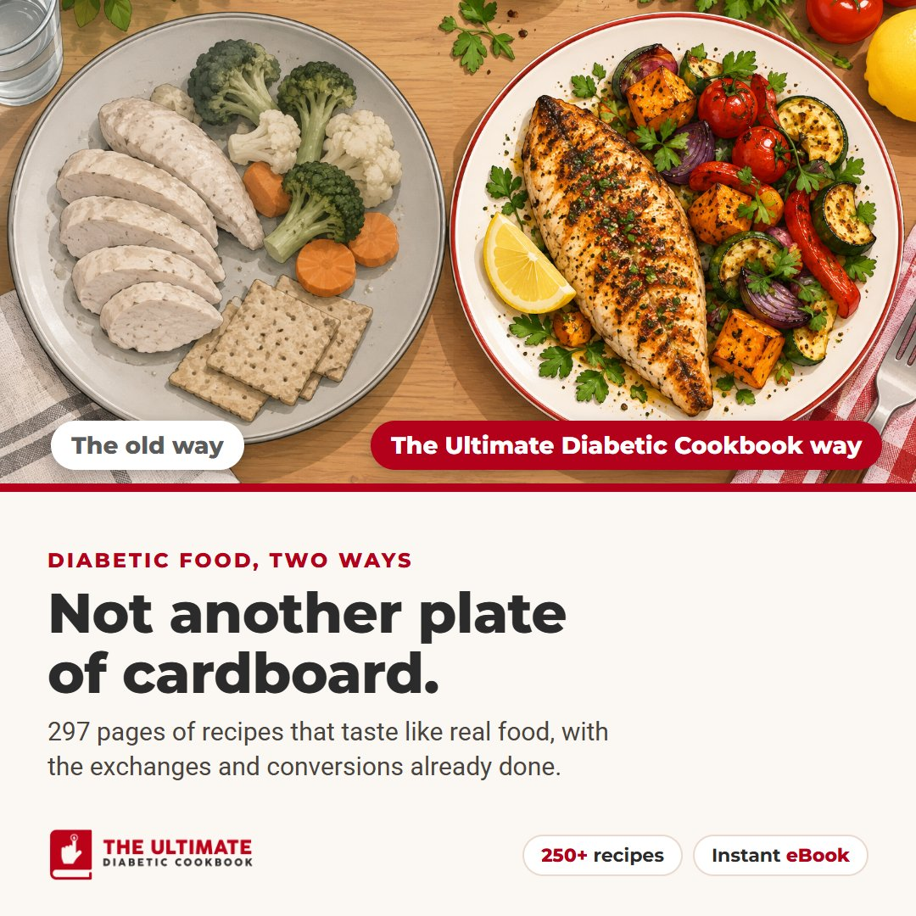
Plain chicken, steamed broccoli and two dry crackers. If that's what diabetic food has come to mean in your house, this cookbook is for you. 297 pages of recipes that taste like real food, with the exchanges and conversions already done for you: {HOPLINK} #ad
Images: social-bland-sq.jpg (square), social-bland-v.jpg (vertical)

3. Dessert is back
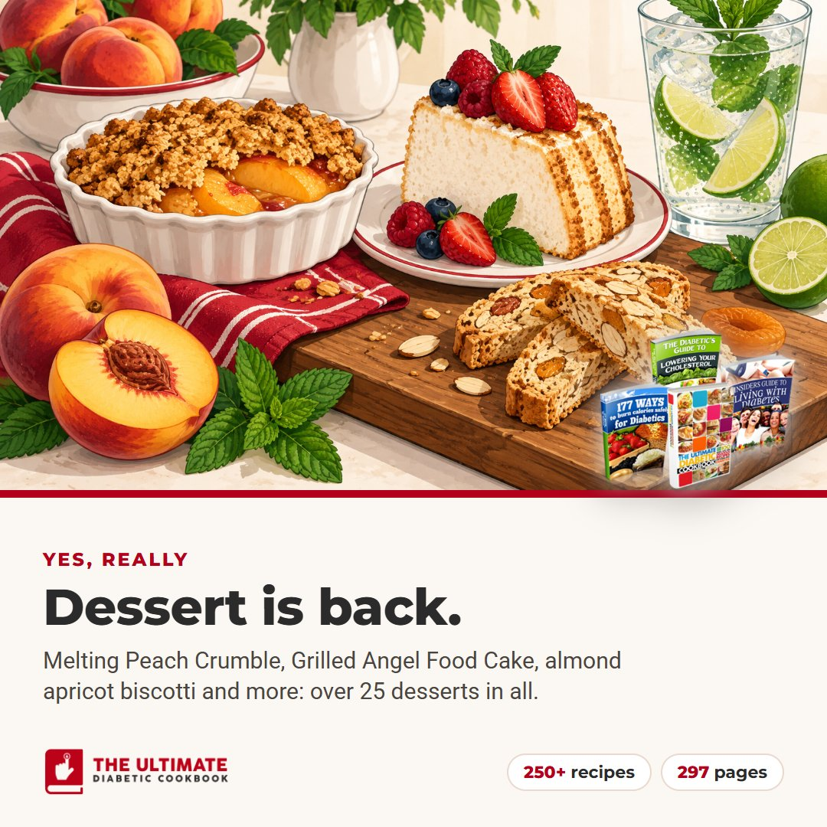
Melting Peach Crumble. Apple Cranberry Pie. Grilled Angel Food Cake. Almond apricot biscotti. They're all in The Ultimate Diabetic Cookbook, along with more than 25 desserts in all and dozens of drinks, hot and cold. See the recipes: {HOPLINK} #ad
Images: social-dessert-sq.jpg (square), social-dessert-v.jpg (vertical)

4. On your screen in minutes
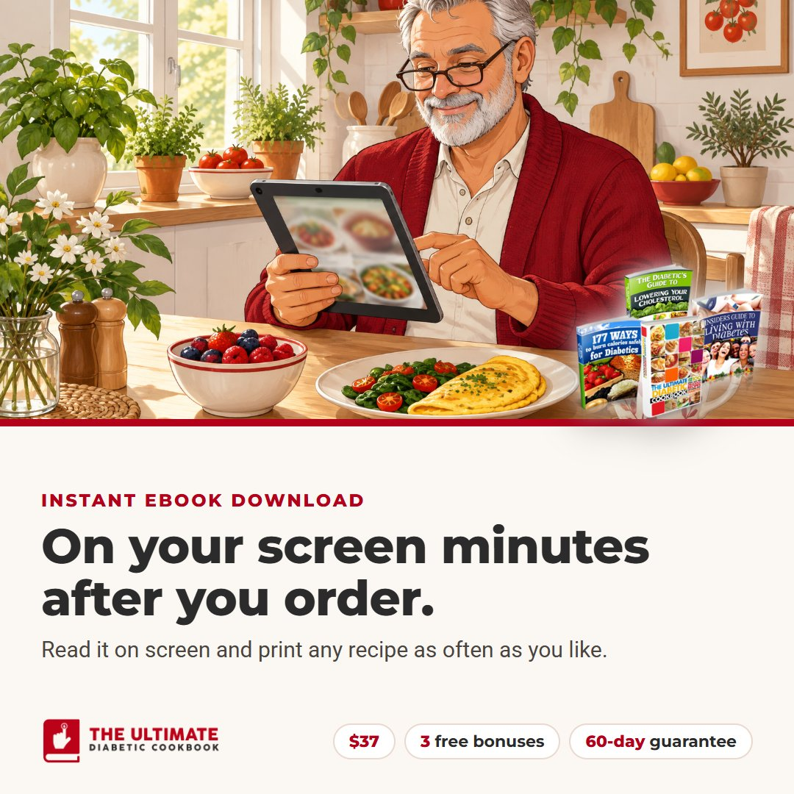
The Ultimate Diabetic Cookbook is an eBook, so you can be reading it a few minutes after you order, and you can print any recipe as often as you like. It's $37, it comes with three free bonus guides, and it has a 60-day money-back guarantee: {HOPLINK} #ad
Images: social-reader-sq.jpg (square), social-reader-v.jpg (vertical)

5. Food the whole table will enjoy
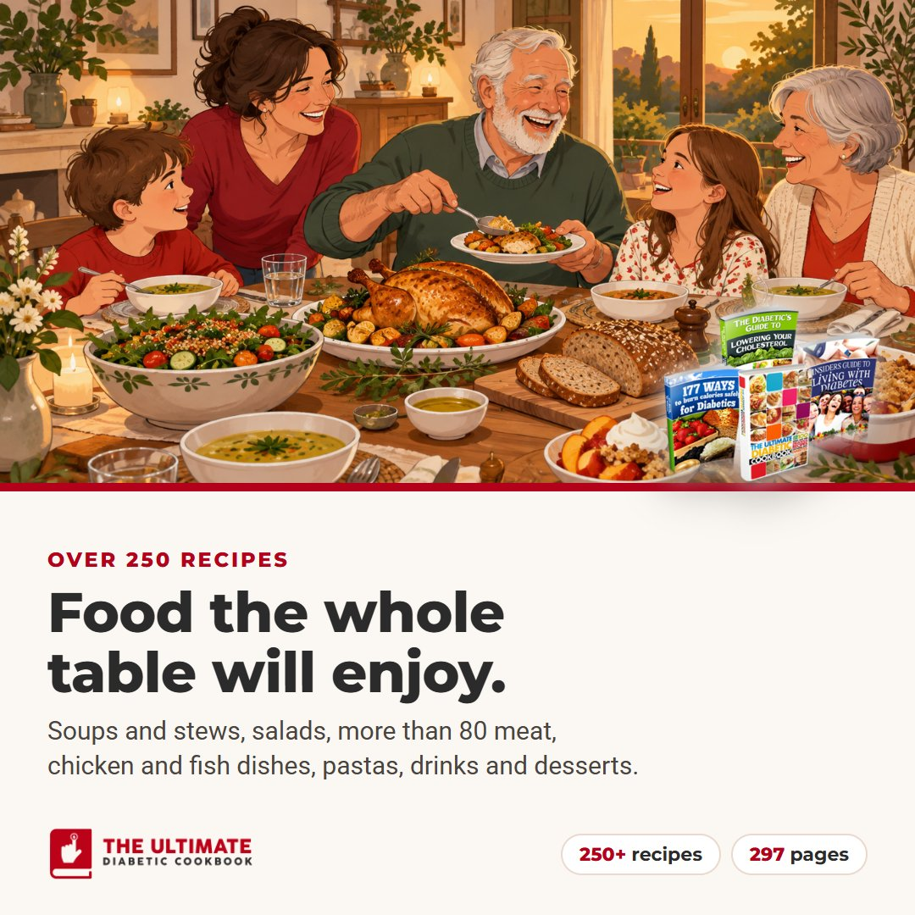
One cookbook for the whole family table: more than 25 soups and stews, salads and veggie dishes, over 80 meat, chicken and fish recipes, grains, pastas, drinks and desserts. The Ultimate Diabetic Cookbook was written for people with diabetes and everyone who cooks for them: {HOPLINK} #ad
Images: social-table-sq.jpg (square), social-table-v.jpg (vertical)

